Ideation Phase

Define the Problem Statements

Date | 17 February 2026
Team ID | LTVIP2026TMIDS66150
Project Name | Prosperity Prognosticator: Machine Learning for Startup Success Prediction
Maximum Marks | 2 Marks

Customer Problem Statement Template : Startup Success Prediction Using Machine Learning
Entrepreneurs, startup founders, and investors are increasingly dependent on data-driven insights to make informed business decisions in highly competitive markets. Startup success is influenced by multiple factors such as funding availability, market conditions, business models, and team strength. However, predicting whether a startup will succeed or fail remains challenging due to uncertainty, limited historical insights, and high failure rates.

Empathy Statement :
Entrepreneurs and investors feel uncertain when making decisions about new startups due to high failure rates and lack of reliable insights. They want data-driven tools that can help them evaluate startup potential, reduce financial risk, and improve decision-making confidence.
Reference : Self-defined problem statement based on project analysis and team discussion
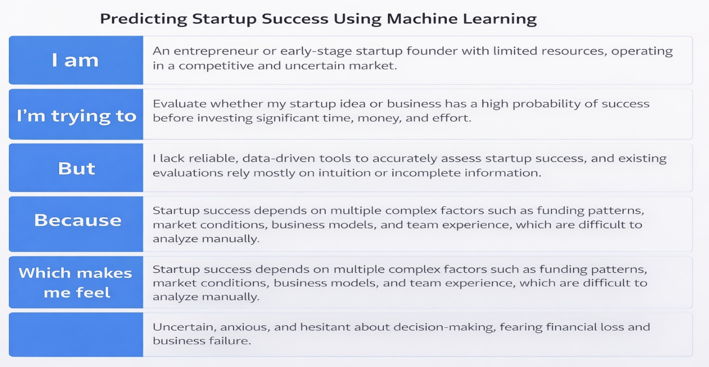

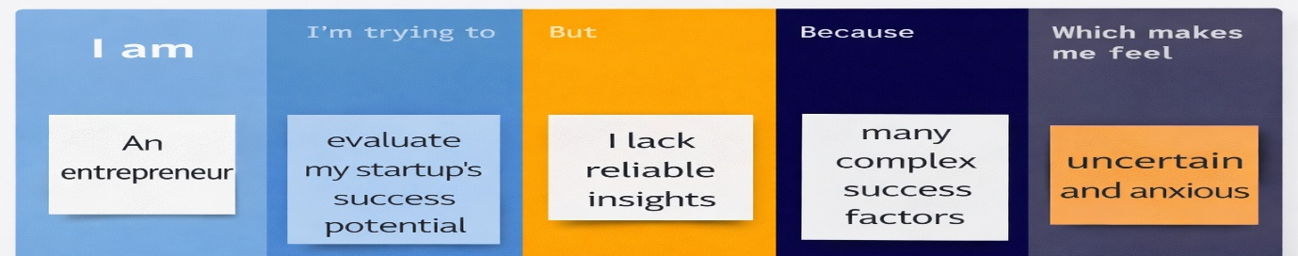
Example:

Problem Statement (PS) | I am | I’m trying to | But | Because | Which makes me feel
PS-1 | I am an entrepreneur | I’m trying to evaluate whether my startup idea is likely to succeed | But I lack access to reliable, data-driven insights | Because startup success depends on multiple complex factors such as funding, market trends, and business characteristics | Which makes me feel uncertain and anxious about investing time and resources
PS-2 | I am an investor | I’m trying to decide which startups are worth investing in | But it is difficult to accurately predict startup success using traditional evaluation methods | Because historical data is vast and complex, and human judgment alone can be biased | Which makes me feel hesitant and worried about financial losses

